Kubernetes Activity1

Client-pod

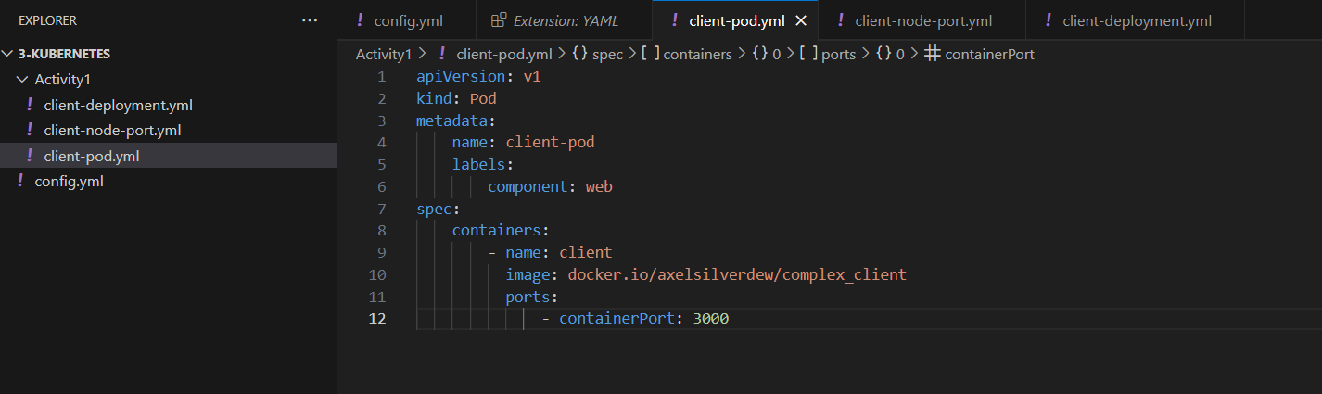

Client-node-port.yml

Run below Kubectl commands in terminal:



